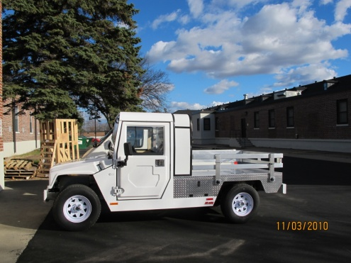
E-Ride Electric Utility Vehicle made in Princeton, MN

