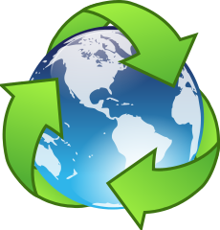
Burnsville Park Nicollet Earth Day Bingo
Turn off lights in your department when not in use | Employee Shred-It | Eat a locally grown fruit or vegetables | Make plans to plant a garden | Take a shorter shower
Pick up litter on PNC grounds | Shut off water when brushing teeth | Turn off monitor at end of the day | Recycle Plastic Lids | Stop by Earth Day Booth on 1st floor
Format document to reduce “white space” | Take a walk outside | Free | Recycle your Caviwipes container when empty | Use a reusable container for your lunch
Print double-sided | Use less paper towels when drying hands | Bring your own plate/fork | Clean off containers that can be recycled | Donate extra supplies to PNC Missions
Bring your own coffee cup/water cup to work | Electronically save documents | Shred all office paper.  We pay a flat rate for Shred-It | Flatten cardboard boxes | Unplug anything that is not in use

